If sigmoid has S-shape curve, then why non-linear boundary can be extracted using logistic regression?
When we take sigmoid of z that means these scores are transformed into s-shaped curve.
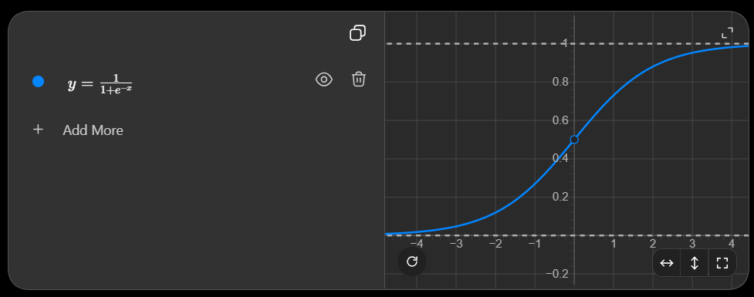
But this curve in not in input-output space. Instead it is in (z)(sigmoid-score) space. From this space, we pick p=0.5 that maps back to z = 0 in i/o space.
Therefore, we get decision boundary z=0 in i/o space.
